EXP.NO:06 | ADT APPLICATION
DATE:19.08.19 | ADT APPLICATION
AIM:
To design a java program for ADT stack and to implement this interface using array by providing necessary handling in both the implementatin by pushing and poping string data
REQUIREMENT:
-knowledge of push and pop
-Exception handling
-Handling of array
-Interface implementation
ALGORITHM:
STEP 1: Start
STEP 2: create classes Mystack,Stack,Calculation and StackException
STEP 3: Define StackException with string in it
STEP 4: Define the interface by using throw exception
STEP 5:To add data define the data type i.e. string for describing different cases define the operation of each case to meet the requirement
STEP 6:Finish the coding with calculation class coding for the required output
STEP 7: Stop
CLASS DIAGRAM:
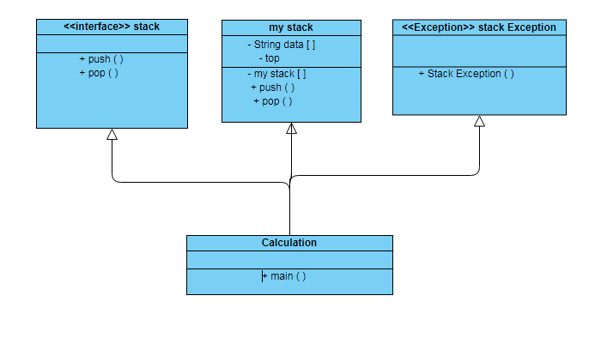
PROGRAM:
/**created by
*sandhiya.A,
* eee-b, 212217105052
* Saveetha Engineering College.
*/
package mystack;
public interface Stack {
public void push(String v) throws StackException;
public String pop() throws StackException;
}
package mystack;
public class StackException extends Exception {
public StackException(String m)
{
super(m);
}
}
package mystack;
public class MyStack implements Stack {
private String data[];
private int top;
public MyStack(int s)
{
top=-1;
data=new String[s];
}
@Override
public void push(String v) throws StackException
{
if(top>=(data.length-1))
{
throw new StackException("Stack Full: It is already having "+(top+1)+" elements");
}
top=top+1;
data[top]=v;
}
@Override
public String pop()throws StackException
{
String result;
if(top<0)
{
throw new StackException("Stack is empty");
}
result=data[top];
top=top-1;
return result;
}
}
package mystack;
import java.util.Scanner;
public class Calculation {
public static void main(String[] args) {
String value1;
int option;
Stack st;
Scanner sc=new Scanner(System.in);
st=new MyStack(5);
while(true)
{
try
{
System.out.println("1. Push a String");
System.out.println("2. Pop a String");
System.out.println("3. Exit");
System.out.print("Enter your choice:");
option=sc.nextInt();
switch(option)
{
case 1:
System.out.print("Enter a String:");
value1=sc.next();
st.push(value1);
System.out.println("Push completed.");
break;
case 2:
value1=st.pop();
System.out.printf("Stack top value=%s\n",value1);
break;
default:
System.out.print("Please enter a valid number !!!");
}
if(option==3)
{
System.out.print("Thankyou for using stack application !!!");
break;
}
}catch(StackException e1)
{
System.out.println("Error:"+e1.getMessage());
}catch(NumberFormatException e2)
{
System.out.println("Error:"+e2.getMessage());
}
}
}
}
OUTPUT:
1. Push a String
2. Pop a String
3. Exit
Enter your choice:1
Enter a String:uday
Push completed.
1. Push a String
2. Pop a String
3. Exit
Enter your choice:1
Enter a String:hari
Push completed.
1. Push a String
2. Pop a String
3. Exit
Enter your choice:1
Enter a String:jaswanth
Push completed.
1. Push a String
2. Pop a String
3. Exit
Enter your choice:2
Stack top value=jaswanth
1. Push a String
2. Pop a String
3. Exit
Enter your choice:2
Stack top value=hari
1. Push a String
2. Pop a String
3. Exit
Enter your choice:3
Please enter a valid number !!!Thankyou for using stack application !!!

RESULT:Hence,A java program for ADT stack and to implement this interface using array by providing necessary handling in both the implementatin by pushing and poping string data is done

